www.aulados.net Geotours Norte Chile 2021
Geotour 1 The Rainbow Valley, San Pedro de Atacama, Chile
A spectacular multicoloured continental Cretaceous hidden in a mountain range amidst the vastness of the desert
R. Oyarzun & P. Cubas
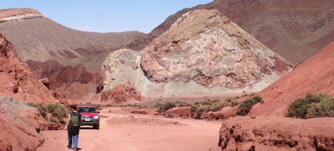The multicoloured landscape of the Rainbow Valley, Antofagasta Region – Chile
Date of visit:
March 29, 2019
Geotour travelers:
C. Cubas, P. Cubas, M. García & R. Oyarzun
Classroom2puntonet- 2021
1
www.aulados.net Geotours Norte Chile 2021
General
Rainbow Valley is located about 90 km north of San Pedro de Atacama. It owes its name to the variety of colours visible in the Cretaceous geological formations that outcrop there: vibrant reds, beiges, greens, whites, and yellows, combined with white salts and a spectacular blue sky. The still relatively unknown Rainbow Valley consequently attracts fewer tourists than the more popular Mars and Moon sites, which, due to their proximity to San Pedro, are more accessible and offer cheaper tours. This is good news in an area that, in many ways, has been "occupied" by hordes of tourists who neither understand nor try to understand the scientific value of this unique region.
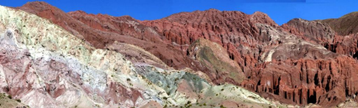Rainbow Valley. From left to right and towards the background, Tonel Intrusives and Tonel Formation
This is an environment that no geologist or person with related knowledge should miss. In fact, the sheer beauty and uniqueness of the place should be reward enough for anyone who visits.
Central coordinates (decimal degrees): -22.641810º (Lat S) -68.240939º (Long W) Altitude:3150 meters above sea level
YouTube: https://www.youtube.com/watch?v=qhDYzU_dqhc
Geology
The eastern edge of the Antofagasta Region (ChileIt is home to one of the most beautiful geological landscapes in the world, the Quaternary to recent volcanoes that line the border with Bolivia and Argentina, part of the Atacama Plateau that developed between about 10 and 1 Ma ago, covering about 70,000 km² with more than 10⁴ km³ of emitted pyroclasts, making this region the largest young province of ignimbrites on Earth (e.g. Allmendinger et al. 1997). To the West appear (by geographical orderThe great depression of the Salar de Atacama and the tectonic block of the Domeyko Range. Immediately northwest of the town of San Pedro de Atacama appears one of the most spectacular regional structures, the so-called Barros Arana Syncline, with a northeast-trending axis for about 50 km and a periclinal closure to the southwest. The syncline is structurally located at the foot of the Domeyko block and is formed
2
www.aulados.net Geotours Norte Chile 2021
mainly by stratified continental sedimentary rocks of the Albian-Maastrichtian and possibly Danian, with the formations (from base to ceiling): Tonel, Purilactis and Barros Arana(Henríquez et al. 2014; this citation remains valid for the following paragraphs).
The sequence (preferably Tonel and partly Purilactis) is cut by the so-called Barrel Hypabyssal Intrusives (Late Cretaceous – Palaeocene). They are dark-green, coarse-grained lamprophyres with porphyritic textures. The green colour of these bodies is not due to the presence of copper (as indicated by some tourist brochures or websites) but to the presence of chlorite and epidote (propylitic alteration). They have phenocrysts of amphibole, pyroxene and plagioclase and exhibit alteration to sericite, clays, epidote and chlorite.
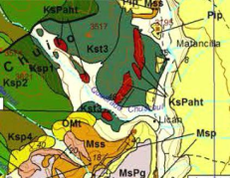

Dike (KsPaht) (arrow) cutting into Barrel (Kst)
Pip: Puripicar Ignimbrite (4.6-4 Ma)
Msp: Bald Ignimbrite (6 Ma)
Mss: Ignimbrite Siphon (9-7.2 Ma)
KsPaht: Tonel Intrusives (Upper Cretaceous-Palaeocene)
MsPg: Gainza Formation (Upper Miocene – Lower Pliocene)
10 km
OMt: Tambores Formation (Upper Oligocene-Lower Miocene) Ksp: Purilactis Formation (Campanian-Maastrichtian)
Kst: Tonel Formation (Albian-Santonian)
Geology of the surroundings of the Rainbow Valley (Henríquez et al. 2014).
The Tonel Formation in Rainbow Valley consists of reddish-brown siltstones and fine sandstones with layers of halite and gypsum, while the Purilactis Formation in the same area consists of fine red, grey, and black sandstones with intercalations of laminated siltstones.
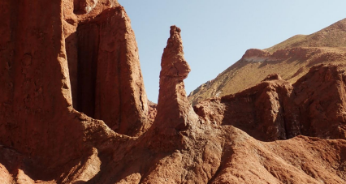Erosional forms in the Tonel Formation.
3
www.aulados.net Geotours Norte Chile 2021
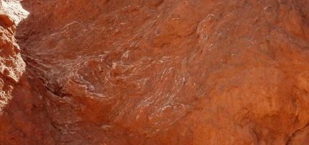
Thin layers of gypsum (arrow) are millimetre to 1-2 cm thick, highly deformed, in layers of fine sediments of the Tonel Formation.
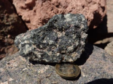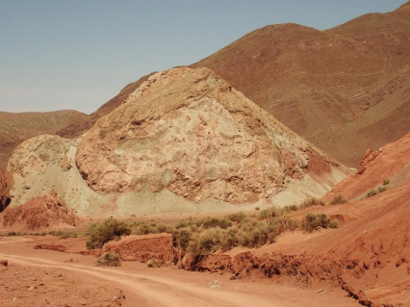
FT
IHT
Tonel hypabyssal intrusives (IHT), dome-shaped formations resembling a snail shell. In the background are layers of the Tonel Formation (FT). Inset: hand sample of the intrusives, with abundant plagioclase, amphibole, and chlorite.
To the north, Purilactis is formed by well-stratified, fine-grained grey, greenish-grey, black, and reddish sandstones. Other sedimentary units, younger than the previous ones, are the Tambores Formation (Late Oligocene-Early Miocene) and the Gainza Formation, which can be seen before entering the valley.
4
www.aulados.net Geotours Norte Chile 2021
Finally, the sedimentary sequences are capped by pyroclastic rocks of the Puripicar Formation (4,6-4 Ma), which are mainly pale pink to light grey tuffs and ignimbrites, generally well-welded, with biotite, quartz, and pumice crystals. Other ignimbrites in the surrounding area include Siphon (9-7.2 Ma) and Baldy (6 May).
A
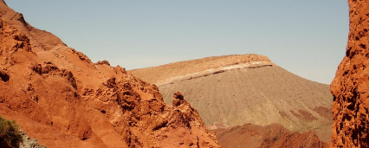
^{Barrel Formation}Ignimbrite Puripicar Colluvium
B
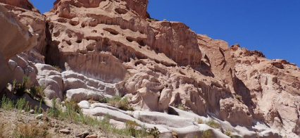Ignimbrite Puripicar
Puripicar Ignimbrite. A: Sealing the Cretaceous formations above (Rainbow Valley). B: Erosional forms of the ignimbrite on the road to San Pedro on the other side of the river.
Bibliographic basis:
R.W. Allmendinger, T.E. Jordan, S.M. Kay & B.L. Isacks (1997) The evolution of the Altiplano-Puna plateau of the central Andes: Annual Review of Earth and Planetary Sciences, 25: 139–174.
S. Henríquez, J. Becerra & C. Arriagada (2014) Geology of the San Pedro de Atacama Area. Antofagasta Region. Geological Map of Chile, Basic Geology Series, no. 171, 99 pp. 1 Map scale 100,000.
5

